Nate Nguyen

IT 207

Lab Practicum 1

March 21, 2021

Link:

<http://helios.ite.gmu.edu/~nnguye76/IT207/lab_practicum/labpracticum_p1.html>

Part 1

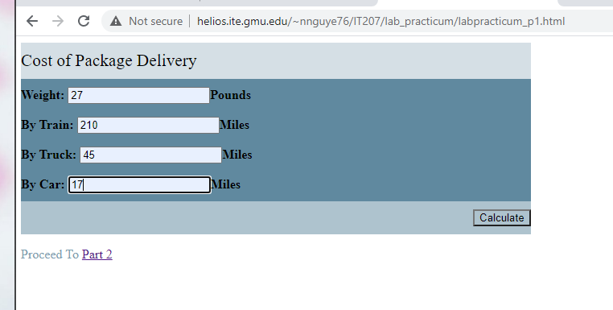

Result

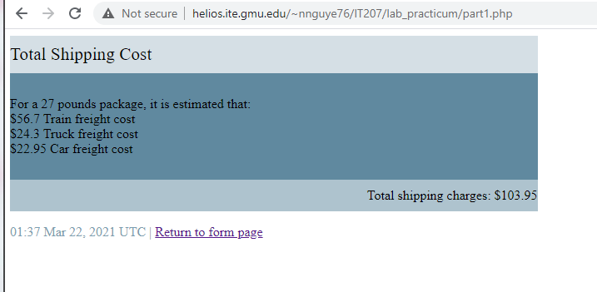

Part 2

